Subject: Iowa House Price Prediction
Data Overview:
The total number of features in the excel “IA_House_Price_Original_Data” are 81 including Sale Price.
The total number of features in the model is 47 (21 numerical features and 26 categorical features: 1 for basement quality and 25 for location).
The features are listed below (Categorical features in blue font):
- Lot area (square feet)
- Overall quality (scale: 1 to 10)
- Overall condition (scale: 1 to 10)
- Year built
- Year remodeled (= year built if no remodeling or additions)
- Finished basement (square feet)
- Unfinished basement (square feet)
- Total basement (square feet)
- First floor (square feet)
- Second floor (square feet)
- Living area (square feet)
- Number of full bathrooms
- Number of half bathrooms
- Number of bedrooms
- Total rooms above grade
- Number of fireplaces
- Parking spaces in garage
- Garage area (square feet)
- Wood deck (square feet)
- Open porch (square feet)
- Enclosed porch (square feet)
- Neighborhood (25 features)
  - CollgCr
  - Veenker
  - Crawfor
  - NoRidge
  - Mitchel
  - Somerst
  - NWAmes
  - OldTown
  - BrkSide
  - Sawyer
  - NridgHt
  - NAmes
  - SawyerW
  - IDOTRR
  - MeadowV
  - Edwards
  - Timber
  - Gilbert
  - StoneBr
  - ClearCr
  - NPkVill
  - Blmngtn
  - BrDale
  - SWISU
  - Blueste
- Basement quality (5,4,3,2,1,0 – based on the quality)

- The data was processed in the following manner:
- The pipeline starts by loading the dataset and mapping raw column names to descriptive labels used throughout the analysis
  - There were 2 columns for Finished Basement (BsmtFinSF1 & BsmtFinSF2) which were merged together to keep the total features to 47
  - ID 2218 and 2219 were removed as they showed NA for Basement_Quality but had a value in the “TotalBsmtSF” column, therefore removed those rows to avoid discrepancy
  - NA in Basement quality were replaced with “NoBsmt” to avoid confusion while running “fill.na”
- Then variables were checked to see if log-transformation was necessary, so as to avoid high right-skewed data points affecting the regression results
  - Checked for right-skewness and then identified if it improved correlation with Sale Price
  - if the log transform improves correlation by at least 0.02 and the variable’s skewness exceeds 1
- The proceeded with updating the “NEIGHBORHOOD” variable into dummy variable. “OldTown” was used as a baseline during the process to avoid multicollinearity issues
- Post that, all the variables (ordinal) were scaled using “StandardScaler()” function as the variables had different scales and were represented using different units
- Feature engineering: We checked if polynomial (squared) terms would better explain the behavior of the Y term and also used linear combinations. They were identified using two approaches. The first one being: Identify the variables whose correlation with the Y term is above 0.6 and then for the selected variables, check the pairs whose correlation is below 0.3. The other method was basically using logic and reasoning to see how the variables would interact with each other.
=== FEATURE ENGINEERING SUMMARY ===
Squared features considered: ['Overall quality', 'Living area (sqft)', 'First floor (sqft)', 'Lot area (sqft)']

Method 1 (Correlation-based):
Number of interaction terms: 10
- Overall quality × Lot area (sqft)
- Overall quality × Overall condition
- Overall quality × Finished basement (sqft)
- Overall quality × Unfinished basement (sqft)
- Overall quality × Second floor (sqft)
- Overall quality × Half bathrooms
- Overall quality × Bedrooms
- Overall quality × Wood deck (sqft)
- Overall quality × Open porch (sqft)
- Overall quality × Enclosed porch (sqft)

Method 2 (Logic-based):
Number of interaction terms: 5
- Overall quality × Living area (sqft)
- Overall quality × First floor (sqft)
- Garage parking spaces × Garage area (sqft)
- Finished basement (sqft) × Total basement (sqft)
- Fireplaces × Total rooms

- The data was split into Train (1800), Validation (600) and Test (506)

- The following parameters were used to check how the R^2 and MSE evolved with each update:
- Rridge_lambdas = [0.10, 0.30, 0.60]
- Lasso_lambdas = [0.02, 0.06, 0.10]

LINEAR REGRESSION
We will explain how linear regression works in this analysis.
Equation:
Y = θ₀ + θ₁*Lot_area + θ₂*Overall_quality + θ₃*Overall_condition + θ₄*Year_built + θ₅*Year_remodeled + θ₆*finished_basement + θ₇*Unfinished_basement + θ₈*Total_basement + θ₉*First_floor + θ₁₀*Second_floor + θ₁₁*Living_area + θ₁₂*N_Full_baths + θ₁₃*N_Half_baths + θ₁₄*N_bedroom + θ₁₅*N_Above_grade + θ₁₆*N_fireplaces + θ₁₇*N_Parking_Spaces + θ₁₈*Garage_area + θ₁₉*Wood_deck + θ₂₀*Open_porch + θ₂₁*Enclosed_porch + θ₂₂*Basement_quality + θ₂₃* Neighborhood_1 + θ₂₄* Neighborhood_2 + θ₂₅* Neighborhood_3 + θ₂₆* Neighborhood_4 + θ₂₇* Neighborhood_5 + θ₂₈* Neighborhood_6 + θ₂₉* Neighborhood_7 + θ₃₀* Neighborhood_8 + θ₃₁* Neighborhood_9 + θ₃₂* Neighborhood_10 + θ₃₃* Neighborhood_11 + θ₃₄* Neighborhood_12 + θ₃₅* Neighborhood_13 + θ₃₆* Neighborhood_14 + θ₃₇* Neighborhood_15 + θ₃₈* Neighborhood_16 + θ₃₉* Neighborhood_17 + θ₄₀* Neighborhood_18 + θ₄₁* Neighborhood_19 + θ₄₂* Neighborhood_20 + θ₄₃* Neighborhood_21 + θ₄₄* Neighborhood_22 + θ₄₅* Neighborhood_23 + θ₄₆* Neighborhood_24
Note: OldTown has the minimum sale price and therefore has been dropped and considered as a baseline for the neighborhood feature.
Vectorized version:
$$h_{θ}=X⋅θ$$
- X → shape (m, n+1) (we’ll add a column of ones for θ₀)
- θ → shape (n+1, 1)
- y → shape (m, 1)
Loss function (Mean Squared Error):
$$J(θ)=\frac{1}{2m}\sum_{i=1}^{m}{*}(h_{θ}(x^{(i)})-y^{(i)})^{2}$$
Gradient:
$$∇_{θ}J\left(θ\right)=\frac{1}{m}X^{T}\left(h_{θ}-y\right)$$
Gradient tells us the direction of steepest move. We then use the gradient descent algorithm to identify the updated theta and see if it is moving towards the minimum or not. For this we also need the learning rate, we helps us in the process. The code using a iterative process updates both the theta value and the learning rate in a way that we converge towards the minimum. “gd_linear” does the following:
- Start with $θ←0$(a (n+1)×1 vector).
- For each iteration $t$up to n_iter:
  - Compute predictions $\hat{y}=X_{b}θ$.
  - Compute gradient $g=\frac{1}{m}X_{b}^{⊤}(\hat{y}-y)$.
  - Update parameters: $θ←θ-η g$where $η=\text{learning rate}$.
  - Compute and record cost $J(θ)$into cost_hist.
- Return final θ and cost_hist.
This is full-batch gradient descent (uses all training examples per gradient step).

In the above, the learning rate is calculated in the below manner:
For each candidate lr
- Initialize θ = 0 and run gradient descent for at most max_iter.
- At each iteration compute cost and append to cost_history.
- Convergence criterion: if $∣J_{t}-J_{t-1}∣<tol$(small change), stop and consider this run converged.
- Divergence detection: if cost explodes (> 2× initial cost after a few steps) then break early for this lr.
- If the run converged and produced a lower cost than the currently best candidate, store this lr, θ, iteration count and cost curve.

Model Selection: The best configuration is chosen based on the highest validation $R^{2}$, ensuring generalization and avoiding overfitting.
Convergence Verification: Gradient descent is rerun using the selected learning rate to confirm the cost function $J(θ)$stabilizes. The process stops when successive changes fall below a small threshold, confirming convergence.
OLS Refit and Rescaling: After convergence, the model is refitted using the Ordinary Least Squares closed-form solution. Coefficients are then transformed back to the original data scale (undoing z-scores) for real-world interpretability.
Statistical Inference: Standard errors, t-statistics, and p-values are computed from the OLS residual variance and covariance matrix, identifying the most statistically significant predictors.

The final model achieved:
- Train R²: 0.8935
- Validation R²: 0.8939
- Test R²: 0.9207
- Validation MSE: 0.1097
- Test MSE: 0.0976
These results indicate that the model explains over 92% of the variance in the unseen test data — demonstrating strong generalization performance.
The smooth convergence curve confirmed a well-chosen learning rate and stable gradient updates.
After feature scaling, the model was refitted using OLS, and coefficients were transformed back to their original units for interpretability. The intercept and coefficients correspond to the expected change in sale price (in dollars) for a one-unit increase in each predictor, holding all others constant.

Final Linear Regression Equation (in Original Units)
$$\text{Predicted Sale Price}=θ_{0}+\sum_{1=1}^{46}{}θ_{i}⋅X_{i}$$
Note: “OldTown” was treated as the baseline neighborhood, and its effect is captured in the intercept.
Interpretation
- Overall Quality, Living Area, and Garage Area were among the strongest positive contributors.
- Older houses (lower Year Built) and smaller lots showed negative associations.
- Neighborhood effects captured local price variation — with higher θ values for upscale areas.
- The log transform of Lot Area helped normalize skewness, improving linear fit.

RIDGE REGRESSION

Ridge regression extends the linear regression framework by introducing an L2 penalty to reduce overfitting and handle multicollinearity among predictors.
While linear regression minimizes the Mean Squared Error (MSE), ridge modifies the loss function by adding a term proportional to the square of coefficient magnitudes.
Equation:
$$J(θ)=\frac{1}{2m}\sum_{i=1}^{m}{}(h_{θ}(x^{(i)})-y^{(i)})^{2}+α\sum_{j=1}^{n}{}θ_{j}^{2}$$
Here,
- $α$(lambda) controls the degree of shrinkage — larger values of $α$force coefficients closer to zero.
- The intercept $θ_{0}$is not regularized, ensuring the mean response remains unbiased.
The model equation remains:
$$\hat{y}=θ_{0}+θ_{1}x_{1}+θ_{2}x_{2}+⋯+θ_{n}x_{n}$$
but each $θ_{j}$is now penalized in proportion to its squared size.

Gradient Descent Update Rule
To optimize Ridge regression via gradient descent, we include the derivative of the penalty term in the gradient:
$$θ:=θ-η(\frac{1}{m}X^{T}(Xθ-y)+\frac{2α}{m}θ)$$
Where:
- $η$= learning rate
- The second term $\frac{2α}{m}θ$shrinks coefficients toward zero with every update.
The adaptive learning rate function iteratively adjusts $η$, rerunning gradient descent until the cost function converges below a small threshold ($ΔJ<{10}^{-6}$).

Algorithm (gd_ridge):
- Initialize: θ ← 0
- For each iteration:
  - Compute predictions: $\hat{y}=X_{b}θ$
  - Compute gradient: $g=\frac{1}{m}X_{b}^{T}(\hat{y}-y)+\frac{2α}{m}θ$
  - Update: $θ←θ-ηg$
  - Record cost: $J(θ)$
- Stop: when cost changes minimally or explodes (divergence check).

Model Selection and Convergence
- Multiple values of $α$(0.1, 0.3, 0.6) are tested.
- For each $α$, adaptive learning rate tuning identifies the best η ensuring convergence.
- The validation R² metric determines the best configuration.
After convergence, the model is refitted using OLS (no penalty) to extract unbiased estimates.
Coefficients are rescaled back to original units for interpretability.

Results Summary:
- Best α (Lambda): 0.1
- Learning Rate (η): 0.1
- Iterations: 838
- Validation R²: 0.9295
- Test R²: 0.9207
- Test MSE: 0.0976
The ridge model achieved nearly identical accuracy to the best linear model but with improved stability and reduced coefficient variance.
Interpretation:
- Ridge performed best with α = 0.1, introducing mild regularization.
- It reduced sensitivity to highly correlated variables, especially Lot Area, 1st Floor, and Basement Area.
- Coefficients with low predictive contribution were slightly shrunk, improving generalization.
- This trade-off between bias and variance made ridge more robust than standard linear regression, especially for unseen data.

LASSO REGRESSION

Lasso regression modifies linear regression by applying an L1 penalty, encouraging sparsity in coefficients.
Unlike Ridge, which shrinks coefficients continuously, Lasso can force some coefficients exactly to zero, effectively performing feature selection.
Equation:
$$J(θ)=\frac{1}{2m}\sum_{i=1}^{m}{}(h_{θ}(x^{(i)})-y^{(i)})^{2}+α\sum_{j=1}^{n}{}∣θ_{j}∣$$
Where:
- $α$controls the strength of the penalty.
- Larger $α$values lead to more aggressive variable selection.
The prediction form remains the same:
$$\hat{y}=θ_{0}+θ_{1}x_{1}+θ_{2}x_{2}+⋯+θ_{n}x_{n}$$
Optimization Approach
Unlike Ridge (which has a closed-form gradient), Lasso uses coordinate descent, updating one coefficient at a time while holding others fixed.
This iterative process is well-suited for the absolute penalty term, which is non-differentiable at zero.
At each step:
- For feature $j$, the algorithm computes a partial residual.
- It then applies soft thresholding:
$$θ_{j}=\{\begin{matrix}s-α, & s>α \\ s+α, & s<-α \\ 0, & ∣s∣≤α\end{matrix}$$
This allows unimportant coefficients to become exactly zero, simplifying the model.

Model Selection and Convergence
- Several λ values are tested (0.02, 0.06, 0.10).
- For each, the coordinate descent algorithm iterates until the cost stabilizes.
- Convergence occurs when successive updates are below a small threshold.
After identifying the best λ, the model is refitted on the full training set and coefficients are re-scaled back to the original data scale.

Results Summary:
- Best α (Lambda): 0.02
- Iterations: 309
- Validation R²: 0.9106
- Test R²: 0.8979
- Test MSE: 0.1257
- Non-zero Coefficients: 20

Interpretation:
- Lasso selected a subset of 20 key predictors, eliminating weaker ones.
- This improves model interpretability while slightly reducing accuracy compared to Ridge.
- Strong predictors retained: Overall Quality, Living Area, Garage Area, Basement Quality, and Neighborhood effects.
- Due to its sparsity, Lasso is highly useful when interpretability and feature reduction are important.

PLOTS AND CHARTS

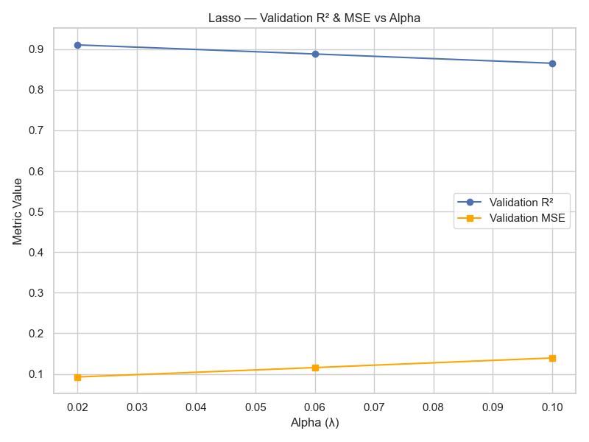

With higher alpha the non-zero variables reduces making the model underfit the data leading to increase in MSE and fall in R^2

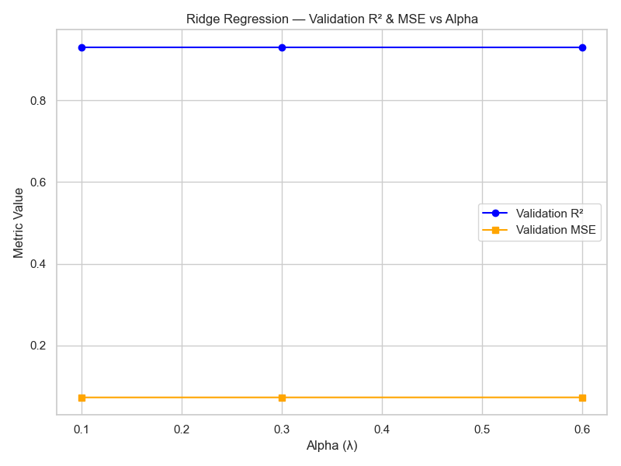

Given the variables have been scaled, and the linear regression has high explanatory power, therefore alpha values produce identical results.

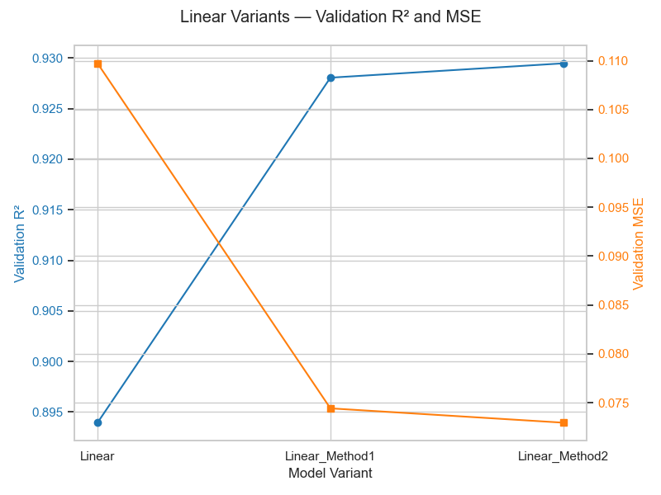

This chart compares validation performance across the three Linear Regression variants.
We observe that R² steadily increases while MSE decreases, indicating Method 2 (logic-based) achieves the best fit and lowest error among all models.

The following characteristics show that Linear Model 2 (with logic based linear combinations terms) has best explanatory power.
Model | Lambda | LearningRate | Iterations | Val_R2 | Test_R2 | Test_MSE
Linear | 0 | 0.1 | 156 | 0.893941 | 0.920733 | 0.097552
Ridge | 0.1 | 0.1 | 838 | 0.929462 | 0.92072 | 0.097568
Lasso | 0.02 |  | 309 | 0.910597 | 0.897889 | 0.125665

